**Experimental characterization and crystal plasticity modeling of dual-phase steels subjected to strain path reversals**

Sowmya Darojua, Taiki Maedab, Toshihiko Kuwabarab, and Marko Knezevica,[1]

aDepartment of Mechanical Engineering, University of New Hampshire, Durham, NH 03824, USA

bDivision of Advanced Mechanical Systems Engineering, Institute of Engineering, Tokyo University of Agriculture and Technology, Tokyo 184-8588, Japan

**Abstract**

This paper…

*Keywords*:

1. **Introduction**

This paper…

1. **Material**

Steels

Table 1. Chemical composition of DP steels (wt%).

|  |  |  |  |  |  |  |  |  |  |
| --- | --- | --- | --- | --- | --- | --- | --- | --- | --- |
|  | C | Mn | P | S | Si | Cu | Ni | Cr | Mo |
| DP 590 | 0.073 | 1.97 | 0.014 | 0.006 | 0.017 | 0.04 | 0.01 | 0.2 | 0.172 |
| DP 780 | 0.1 | 2.163 | 0.015 | 0.006 | 0.014 | 0.03 | 0.01 | 0.26 | 0.332 |
| DP 980 | 0.11 | 2.411 | 0.013 | 0.005 | 0.013 | 0.027 | 0.009 | 0.255 | 0.385 |
| DP 1180 | 0.168 | 2.222 | 0.015 | 0.0053 | 1.421 | 0.021 | 0.007 | 0.036 | 0.013 |
| MS 1700 | 0.59 | 0.2 | <0.002 | <0.001 | 1.98 | - | - | 0.99 | 0.94 |

|  |  |  |  |  |  |  |  |  |
| --- | --- | --- | --- | --- | --- | --- | --- | --- |
|  | Sn | Al | Zr | V | Cb | Ti | B | N2 |
| DP590 | 0.002 | 0.045 |  | 0.001 |  |  | 0.0001 | 0.005 |
| DP780 | 0.003 | 0.048 |  | 0.001 | 0.003 | 0.001 | 0.0001 | 0.006 |
| DP980 | 0.006 | 0.049 | 0.005 | 0.011 | 0.004 | 0.002 | 0.0001 | 0.0033 |
| DP1180 | 0.007 | 0.051 | 0.005 | 0.012 | 0.007 | 0.039 | 0.0004 | 0.0086 |
| MS 1700 | - | - | - | - | - | - | - | - |

**Ref:** <https://iopscience.iop.org/article/10.1088/1468-6996/11/2/025005/meta>

Table 2. Volume fraction of martensite for the studied steels.

|  |  |  |  |  |
| --- | --- | --- | --- | --- |
| DP 590 | DP 780 | DP 980 | DP 1180 | MS 1700 |
| 7.7% | 34% | 39% | 45% | 90% |

1. **Material model**
2. **Results**

*4.1 Experimental results*

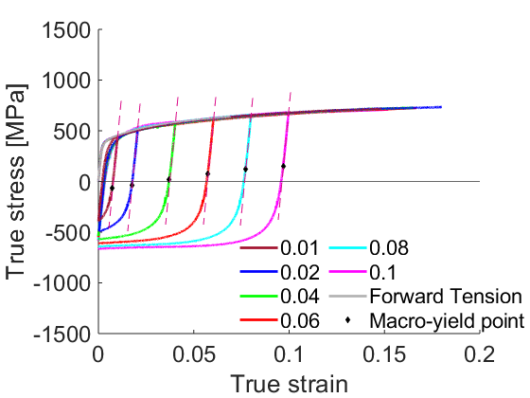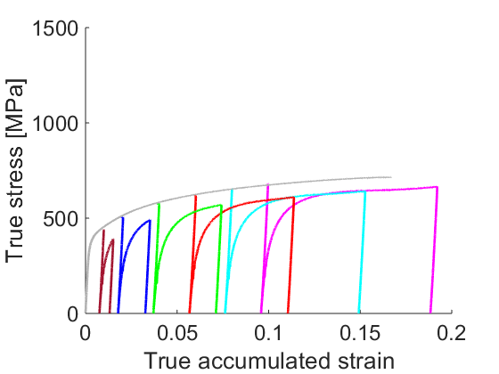

a'

a

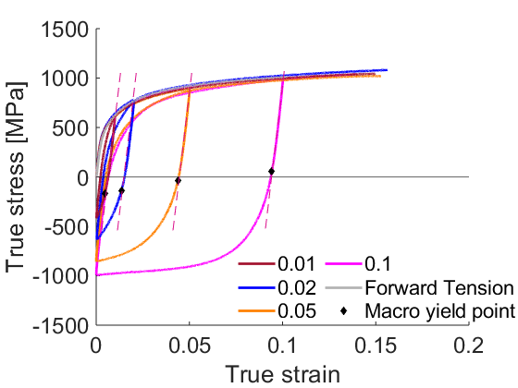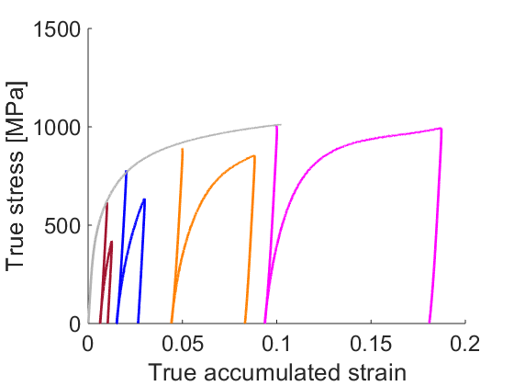

b

b'

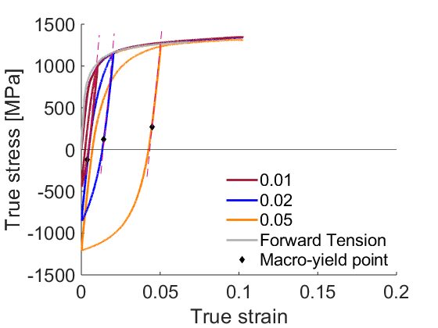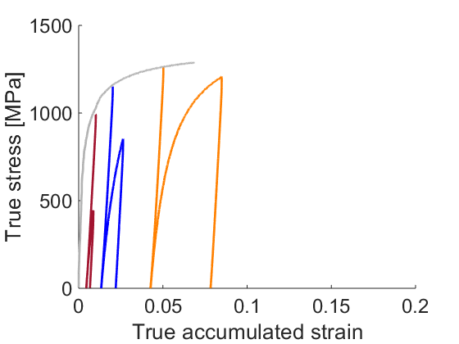

c'

c

Figure 1. True stress–true strain curves during strain path reversals at several large strain levels for (a) DP 590, (b) DP 780, and (c) DP 1180 measured along the rolling direction (RD). Macro-yield points during unloading at approximately 0.001 offset are indicated. Comparison of forward tension versus the 1st reversal curves as a function of accumulated true strain showing drops in the flow stress i.e. the permanent softening effect upon reversals for (a’) DP 590, (b’) DP 780, and (c’) DP 1180.

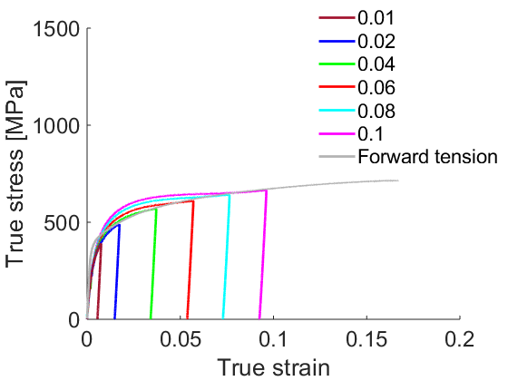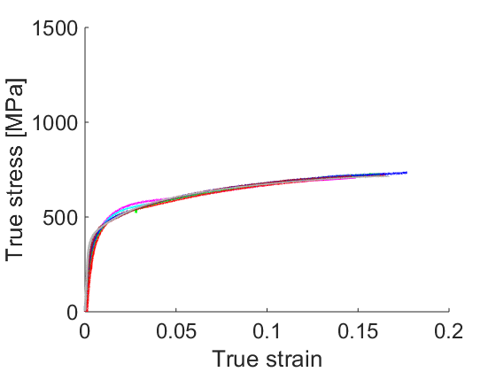

a

a'

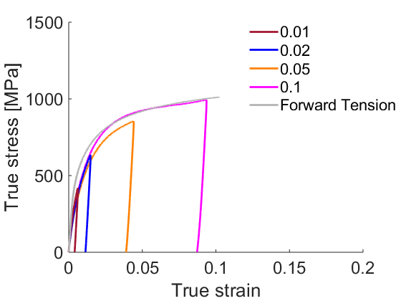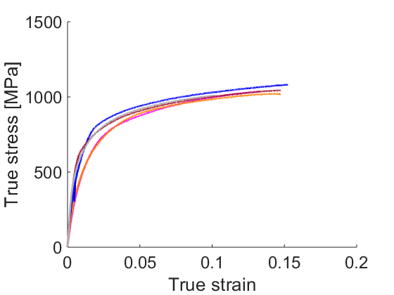

b

b'

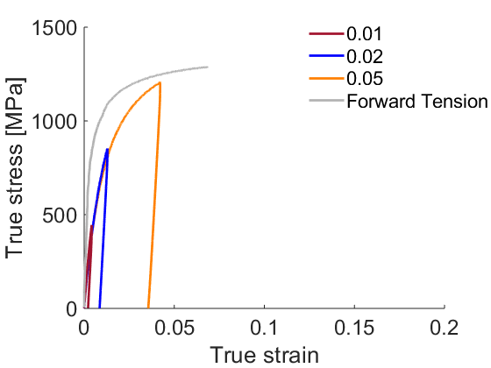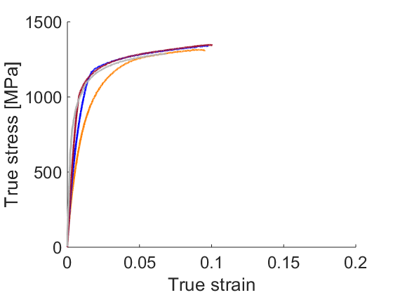

c

c'

Figure 2. Comparison of the forward tension versus the 1st reversal (i.e. compression) curves pre-strained in tension to different strain levels for (a) DP 590, DP 780, and (c) DP 1180. Comparison of the forward tension versus the 2nd reversal (i.e. tension) curves pre-strained in tension followed by compression to different strain levels for (a’) DP 590, (b’) DP 780, and (c’) DP 1180.

*4.2 Model calibration*

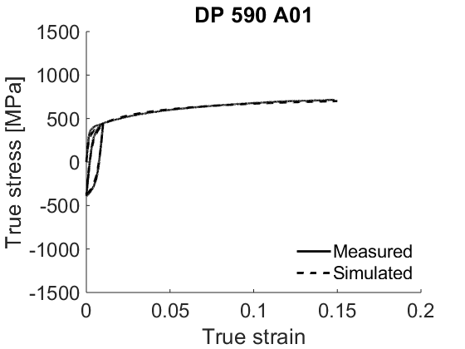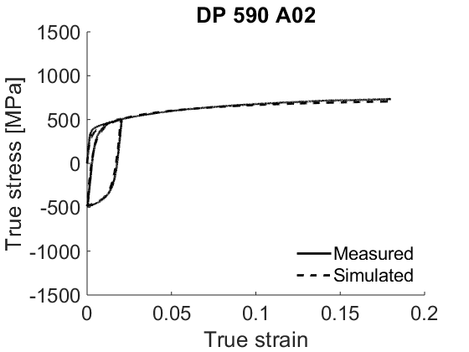

b

a

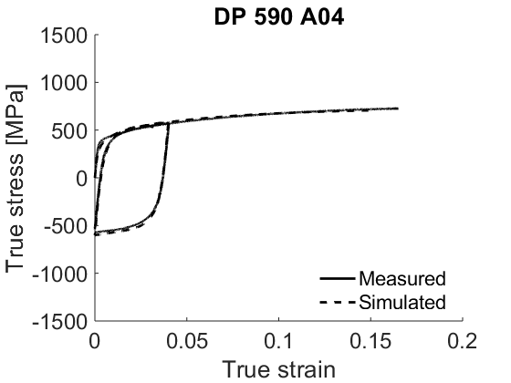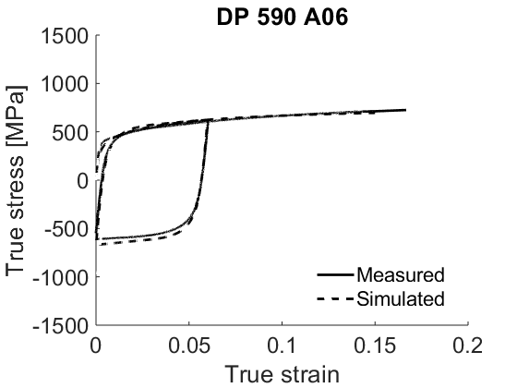

c

d

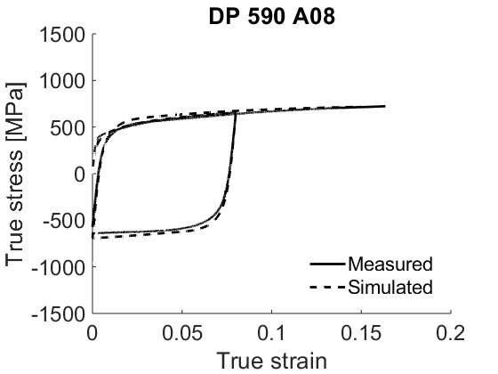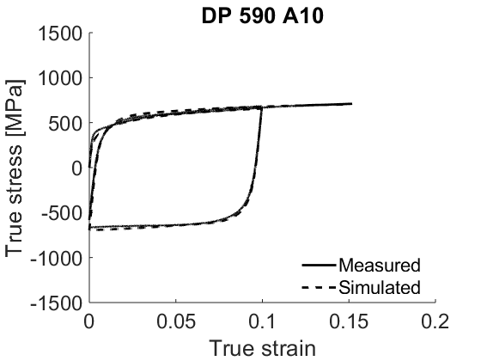

f

e

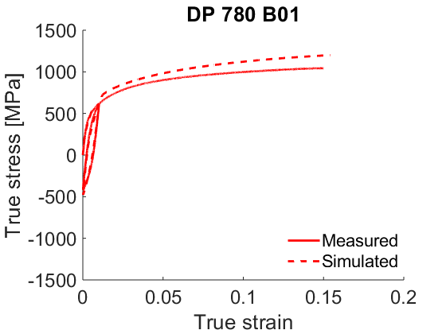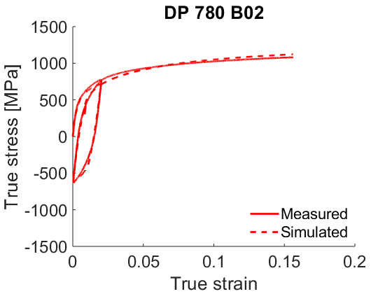

h

g

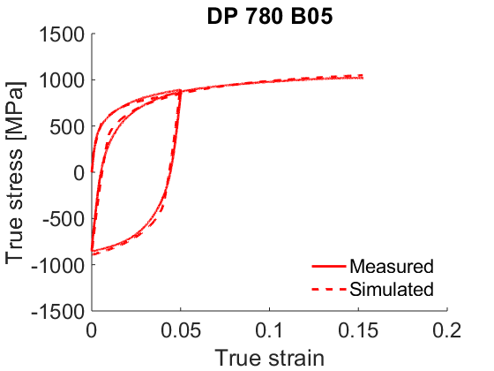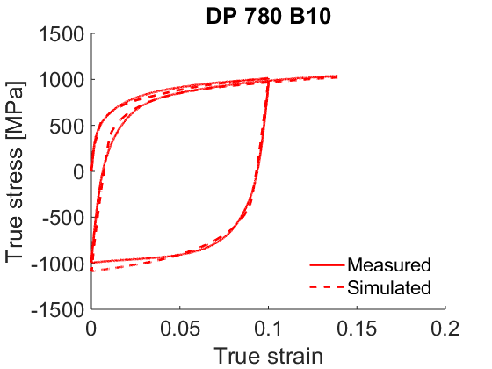

j

i

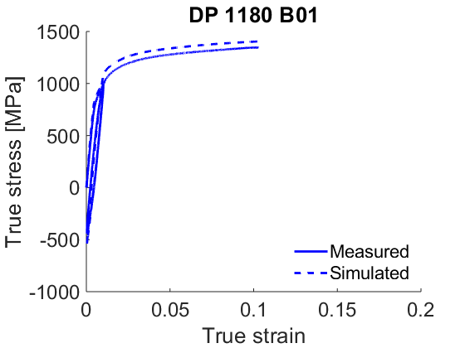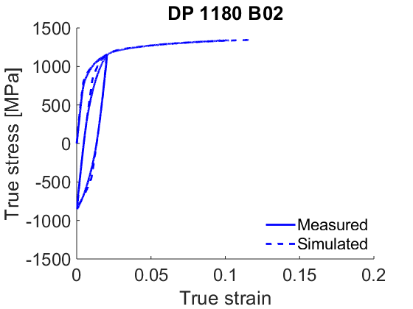

l

k

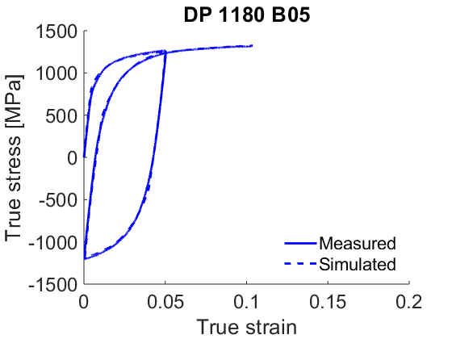

m

Figure 3. Comparison of measured and simulated true stress-true strain response during strain path load reversals for (a - f) DP 590, (g - j) DP 780, and (k - m) DP 1180.

Table 3. Fitting parameters pertaining to the evolution of slip resistance for and slip modes. The Burgers vector is 2.48e-10m.

|  |  |  |  |  |  |  |  |  |  |  |
| --- | --- | --- | --- | --- | --- | --- | --- | --- | --- | --- |
| Parameters | DP 590  (F) | DP 590  (M) | DP 780  (F) | DP 780  (M) | DP 980  (F) | DP 980  (M) | DP 1180  (F) | DP 1180  (M) | MS 1700  (F) | MS 1700  (M) |
| K1α (m-1) | 2.5e8 | 1.5e8 | 2.5e8 | 1.5e8 | 2.5e8 | 1.5e8 | 2.5e8 | 1.5e8 | 2.5e8 | 1.5e8 |
| friction term | 45 | 500 | 45 | 500 | 45 | 500 | 45 | 500 | 45 | 500 |
| ρfor | 8e10 | 1e10 | 3e11 | 8e10 | 1e12 | 3e11 | 4e12 | 8e11 | 4e12 | 8e12 |
| τ0α [MPa] | 66.164 | 508.702 | 81.69 | 526.55 | 111.99 | 551.425 | 186.83 | 577.83 | 194.65 | 764.24 |
| gα | 0.009 | 0.01 | 0.009 | 0.02 | 0.009 | 0.01 | 0.009 | 0.01 | 0.009 | 0.01 |
| Dα | 650 | 700 | 700 | 750 | 750 | 780 | 800 | 850 | 850 | 900 |
| τbssat [MPa] | 55 | N/A | 100 | N/A | 110 | N/A | 150 | N/A | 190 | N/A |
| υ | 1000 | N/A | 100 | N/A | 1000 | N/A | 1000 | N/A | 1000 | N/A |
| γb | 0.001 | N/A | 0.003 | N/A | 0.001 | N/A | 0.005 | N/A | 0.004 | N/A |
| A | 2 | N/A | 3.5 | N/A | 1 | N/A | 2 | N/A | 2 | N/A |

*4.3 Model verification*

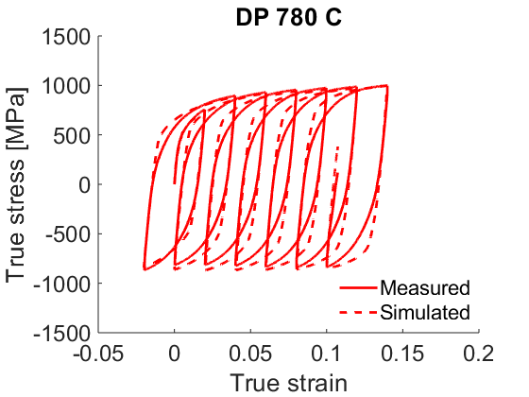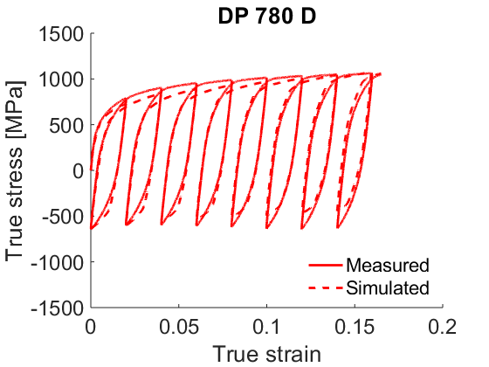

b

a

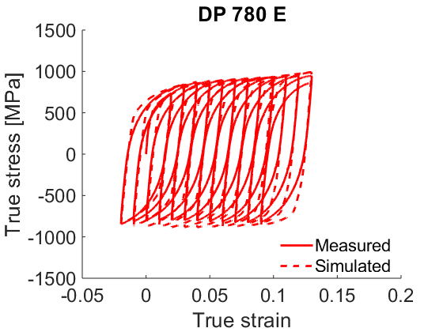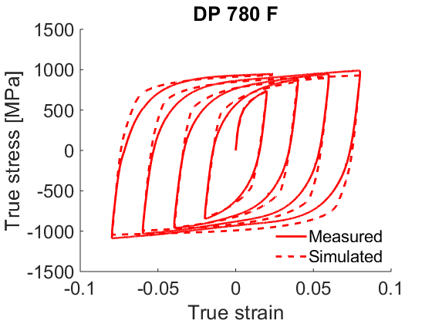

c

d

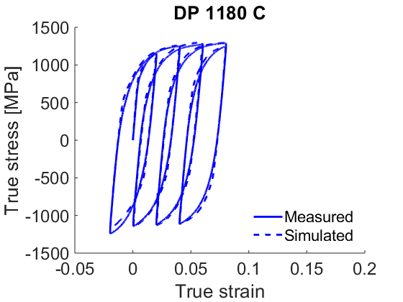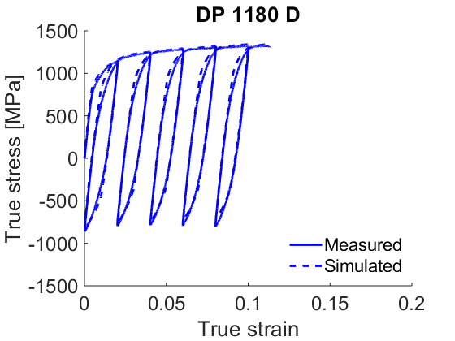

f

e

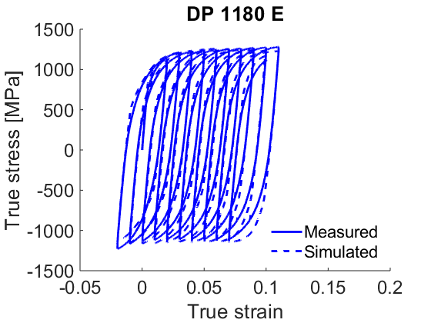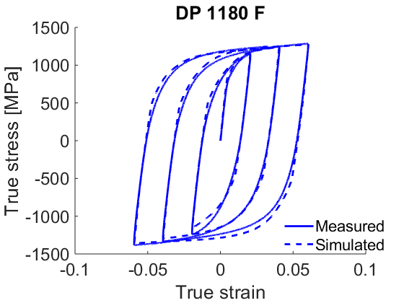

g

h

Figure 4. Comparison of measured and predicted true stress-true strain response during large strain reversals for (a - d) DP 780, and (e - h) DP 1180. The strain path in (a, e) is: 0 → 0.02 → -0.02 → 0.04 → 0 → 0.06…up to fracture with the strain amplitude of 0.04 and the mean strain increase of 0.02 per cycle. The strain path in (b, f) is: 0 → 0.02 → 0 → 0.04 → 0.02 → 0.06…up to fracture with the strain amplitude of 0.02 and the mean strain increase of 0.02 per cycle. The strain path in (c, g) is: 0 → 0.02 → -0.02 → 0.03 → -0.01 → 0.04…up to fracture with the strain amplitude of 0.04 and the mean strain increase of 0.01 per cycle. The strain path in (d, h) is: 0 → 0.02 → -0.02 → 0.04 → -0.04 → 0.06…up to fracture.

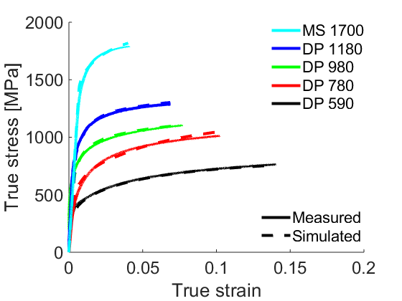

Figure 5. Comparison of measured and predicted true stress-true strain response in simple tension for the studied steels.

Table 4. Properties based on the flow curves from Fig. 5.

|  |  |  |  |  |  |
| --- | --- | --- | --- | --- | --- |
|  | DP 590 (RD) | DP 780 (RD) | DP 980 (RD) | DP 1180 (RD) | MS 1700 (RD) |
| 0.2% offset yield stress (MPa) | 407 | 528 | 630 | 839 | 1487 |
| UTS (MPa) | 663 | 913 | 987 | 1194 | 1778 |
| Eng. strain at UTS | 0.146 | 0.109 | 0.0808 | 0.0619 | 0.0407 |
| Eng. strain at fracture | 0.187 | 0.1318 | 0.0971 | 0.0767 | 0.0420 |

1. **Discussion**

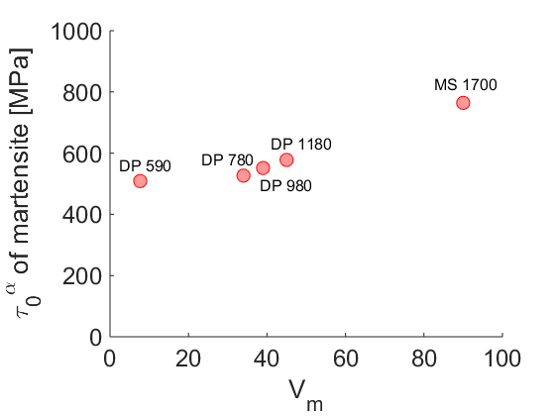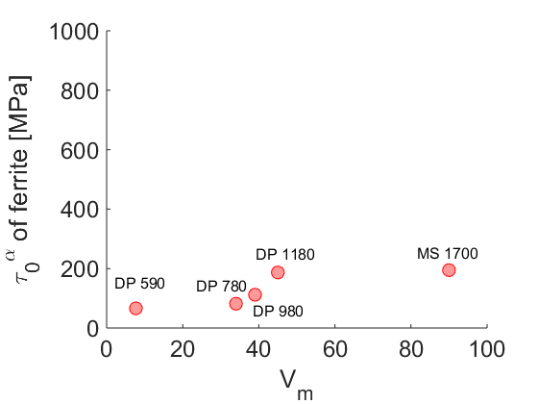

b

a

Figure 6. Dependence of the initial slip resistance on the content of martensite established for the studied steels for (a) martensite and (b) ferrite.

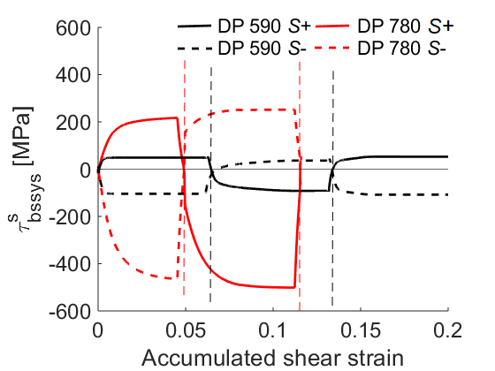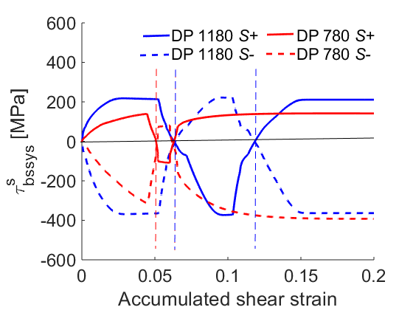

b

a

Figure 7. Evolution of backstress with accumulated shear strain in a randomly selected ferrite grain for the *s*th slip system with highest activity during the forward tension and the 1st and the 2nd reversal for (a) DP 590 versus DP 780 and (b) DP 780 versus DP 1180. The grain has the same crystal orientation for all and the same slip system in the grain is plotted for all.

a

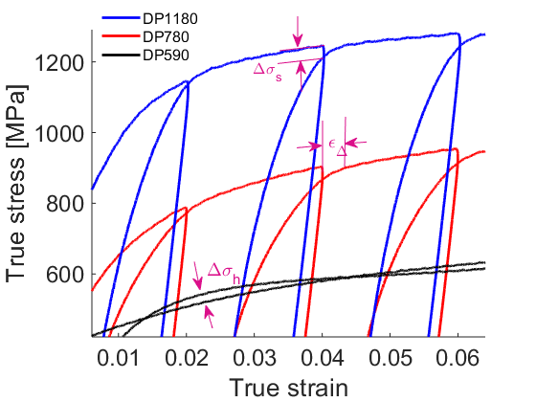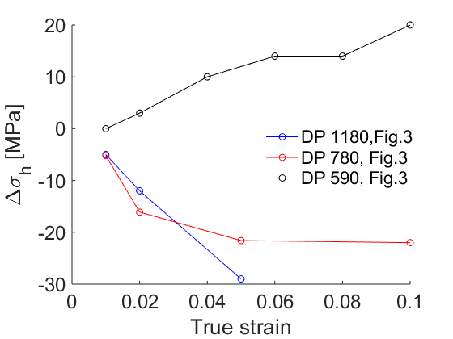

b

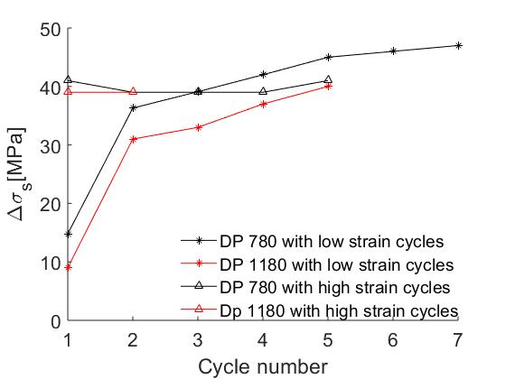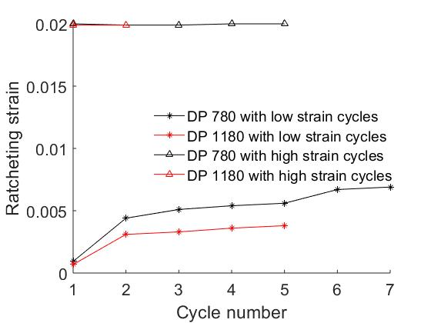Figure 8. (a) Illustration of reloading yield effect (Δ*σ*h), reloading softening (Δ*σ*s), and ratcheting strain (*ε*Δ). (b) Comparison of Δ*σ*h versus true strain levels for tension and compression. (c) Comparison of Δ*σ*s with cycles for tension and compression. Comparison of εΔ with cycles for tension and compression. (e) Unloading deviation stress (Δ*σ*)..

d

c

1. **Conclusions**

References

1. * Corresponding author at: University of New Hampshire, Department of Mechanical Engineering, 33 Academic Way, Kingsbury Hall, W119, Durham, New Hampshire 03824, United States. Tel.: 603 862 5179; fax: 603 862 1865.

   E-*mail address*: [marko.knezevic@unh.edu](mailto:marko.knezevic@unh.edu) (M. Knezevic).